# **Lab Number : 01 Date:** **June 13th, 2025**

# **Title : Understanding the basic Network Equipment**

1. **Theory**

1.1 **Network Equipment**

Network equipment refers to the physical devices used to connect computers, printers, phones, and other hardware in a network. They manage traffic, ensure security, and enable communication between nodes.

* + 1. **Repeater**

A repeater is a device that regenerates and amplifies signals to extend the transmission

distance of the network. It receives a signal and retransmits it at a higher power so that the

signal can cover longer distances without degradation.

**Function:** Extends network signal range by regenerating and amplifying signals.

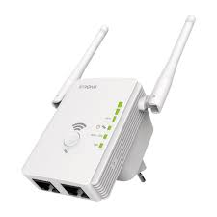

**Fig. 1.1 Repeater**

* + 1. **Hub**

A hub is a basic networking device that connects multiple Ethernet devices, making them act as a single network segment. Hubs operate at the physical layer (Layer 1) of the OSI model and broadcast data to all connected devices.

**Function:** Connects multiple Ethernet devices and broadcasts data to all devices in a network.

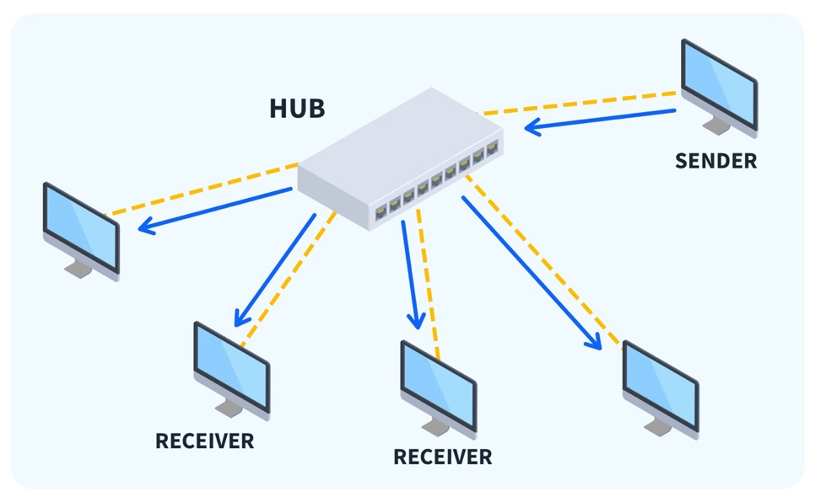

**Fig. 1.2 Hub**

* + 1. **Switch**

A switch is a device that filters and forwards packets between LAN segments. Unlike hubs, switches operate at the data link layer (Layer 2) and can identify specific devices within a network, directing data only to the intended recipient.

**Function:** Directs data only to the intended recipient device within a network, enhancing efficiency.

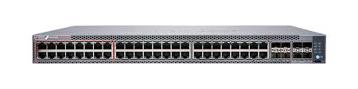

**Fig. 1.3 Switch**

* + 1. **Bridge**

A bridge connects and filters traffic between two network segments. It operates at the data link layer and can reduce network traffic by dividing the network into separate collision domains.

**Function:**Connects and filters traffic between two network segments, managing traffic flow.

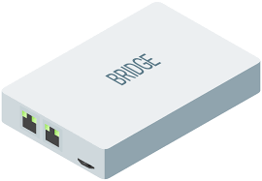

**Fig. 1.4 Bridge**

* + 1. **Router**

A router forwards data packets between computer networks, operating at the network layer (Layer 3) of the OSI model. Routers determine the best path for data to travel from source to destination.

**Function:** Forwards data packets between networks, determining the best path for data.

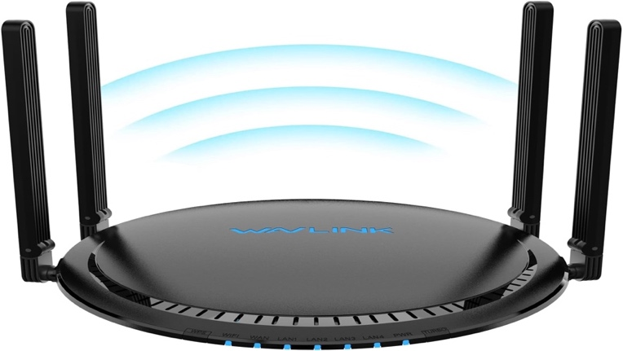

**Fig 1.5: Router**

* + 1. **Modem**

A modem modulates and demodulates signals for data transmission over phone lines. It

converts digital data from a computer into analog signals for transmission and vice versa.

**Function:** Converts digital data to analog signals for transmission over phone lines and

vice versa.

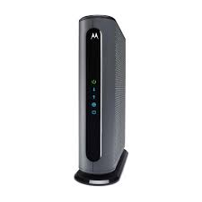

**Fig 1.6: Modem**

* + 1. **Network Interface Card (NIC)**

A Network Interface Card is a hardware component that allows a computer to connect to a network. It provides the physical interface for network communication and a unique MAC address for identifying the device on the network.

**Function:** It translates data between the computer and the network, handling framing, error detection, MAC addressing, and managing reliable data transmission and access control.

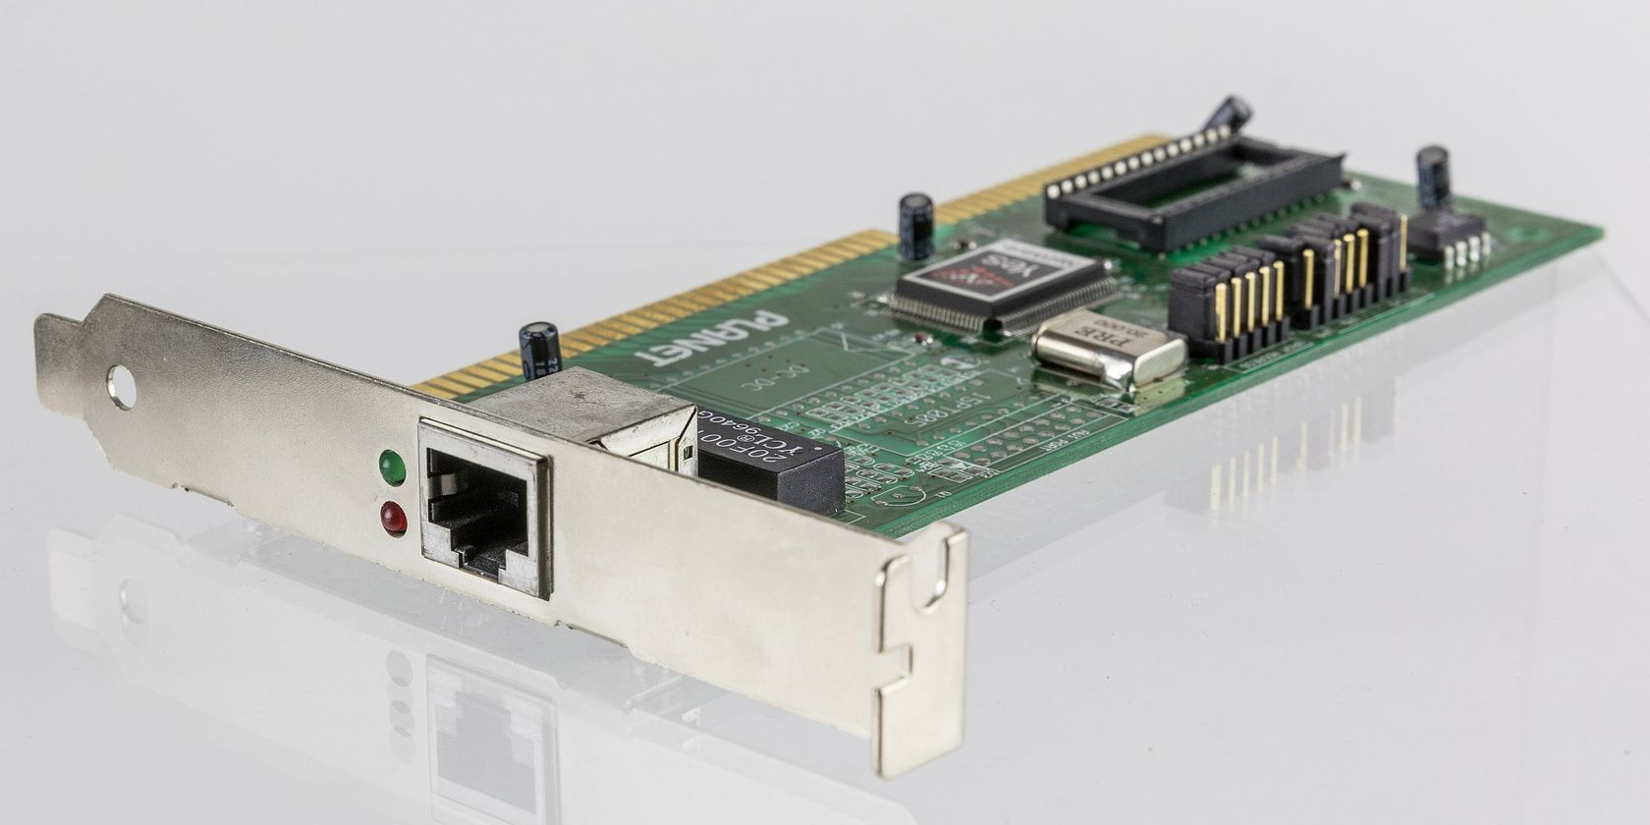

**Fig 1.7: Network Interface Card**

* + 1. **Firewall**

A firewall monitors and controls incoming and outgoing network traffic based on

predetermined security rules. It serves as a barrier between a trusted internal network and

untrusted external networks.

**Function:** Monitors and controls network traffic to protect against unauthorized access.

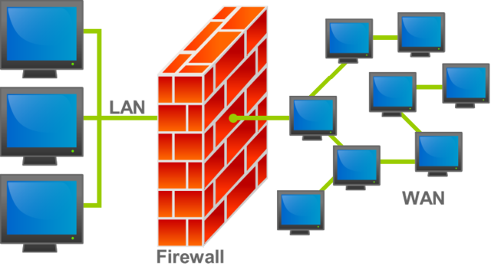

**Fig 1.8: Firewall**

* + 1. **Wireless Access Point (WAP)**

A WAP allows wireless devices to connect to a wired network using Wi-Fi. It acts as a

central transmitter and receiver of wireless radio signals.

**Function:** Enables wireless devices to connect to a wired network via Wi-Fi.

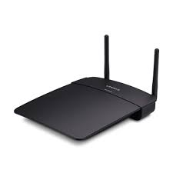

**Fig 1.9: Wireless Access Point**

* + 1. **VoIP Endpoint**

A VoIP endpoint refers to devices such as IP phones or VoIP adapters that enable voice

communication over IP networks.

**Function:** Facilitates voice communication over IP networks by converting voice signals

to digital data.

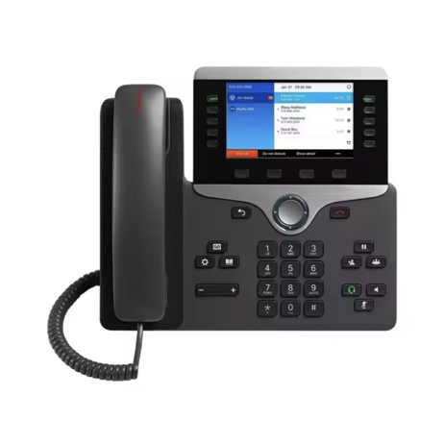

**Fig 1.10: VoIP Endpoint**

**Conclusion**

Understanding the role of each network device was essential for grasping the fundamentals of modern computer networking. Devices like repeaters, hubs, switches, bridges, routers, and modems each had specific functions that contributed to the efficient flow of data. Network Interface Cards enabled communication between devices, while firewalls provided security by filtering traffic. Wireless Access Points allowed wireless connectivity, and VoIP endpoints supported voice communication over IP networks. This lab helped us connect theory with real-world application by showing how these components worked together in a functional network. It provided a strong foundation for future studies and practical networking tasks.

# **Lab Number : 02 Date:** **June 13th, 2025**

# **Title : Understanding the Ethernet Wiring in detail**

**1.Theory**

* 1. **Network Equipment Details**
     1. **UTP (Unshielded Twisted Pair) Cat5e/Cat6 cables**

**Function:** Transmits data signals in a network.

**Use:** Utilized to create straight-through and crossover cables for connecting various

network devices such as computers, switches, and routers.

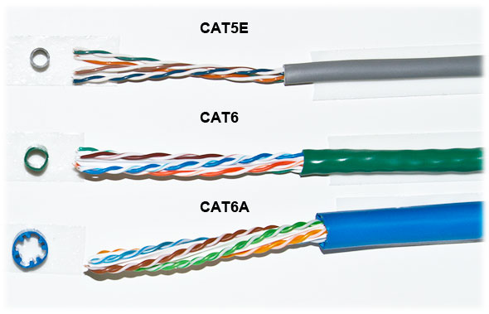

**Fig 1.1: UTP Cables**

* + 1. **RJ-45 connectors**

**Function:** Terminates the ends of UTP cables for insertion into network devices.

**Use:** Attached to the ends of Category 5e or Category 6 cables to create reliable

connections between network devices.

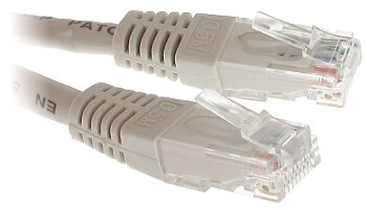

**Fig 1.2: RJ-45 connectors**

* + 1. **Crimping tool**

**Function:** Secures RJ45 connectors to the ends of UTP cables.

**Use:** Used to crimp the RJ45 connectors onto the cables, ensuring a secure and stable

connection.

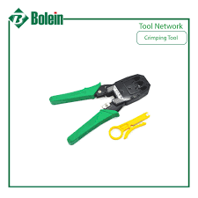

**Fig 1.3: Crimping Tool**

* + 1. **Cable tester**

**Function:** Verifies the integrity and functionality of network cables.

**Use:** Used to test the straight-through and crossover cables after assembly to ensure they

are wired correctly and functioning properly.

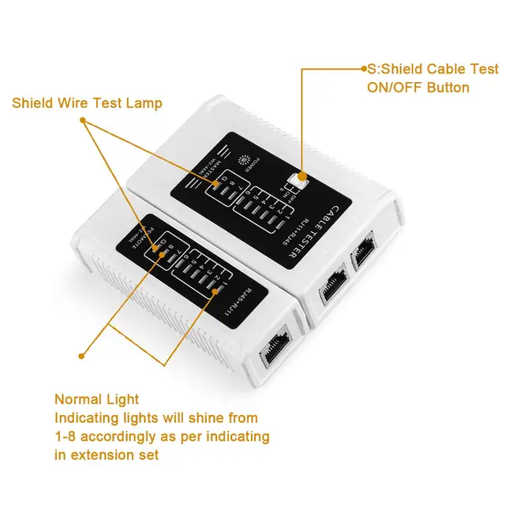

**Fig 1.4: Cable Tester**

* + 1. **Wire stripper**

**Function:** Removes the outer insulation from UTP cables.

**Use:** Employed to strip the outer jacket of the cables to expose the individual wires for arranging and connecting to RJ45 connectors.



**Fig 1.5: Wire Stripper**

* + 1. **Scissors**

**Function:** Cuts cables and trims excess wire.

**Use:** Used to cut UTP cables to the desired length and to trim wires to the correct length

before inserting them into RJ45 connectors.

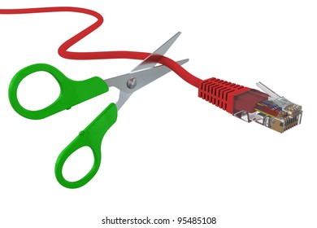

**Fig 1.6: Scissors**

* + 1. **Punch Down Tool**

**Function:** A punch down tool is used to insert and secure wires into insulation displacement connectors (IDCs) on punch down blocks, patch panels, and keystone jacks.It trims the excess wire as it punches the wire down into the connector.

**Use:** **Terminating Ethernet cables on a patch panel:** The punch down tool is used to insert and secure individual wires from an Ethernet cable into the IDC terminals of a patch panel.

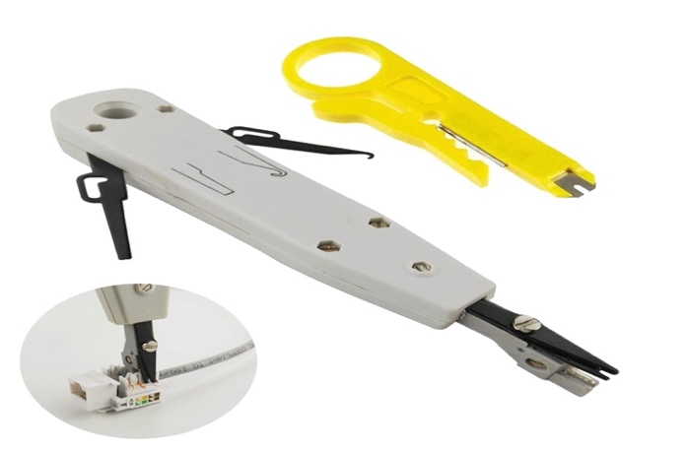

**Fig 1.7: Punch Down Tool**

* + 1. **Keystone Jacks**

**Function:** Keystone jacks are modular connectors used primarily in data communications

and networking. They provide a standardized interface for connecting Ethernet cables to

network devices or patch panels.

**Creating network outlets:** Keystone jacks are used to terminate Ethernet cables and

mount them into wall plates or patch panels, creating network outlets that facilitate easy

and organized connections for devices within a local area network (LAN).

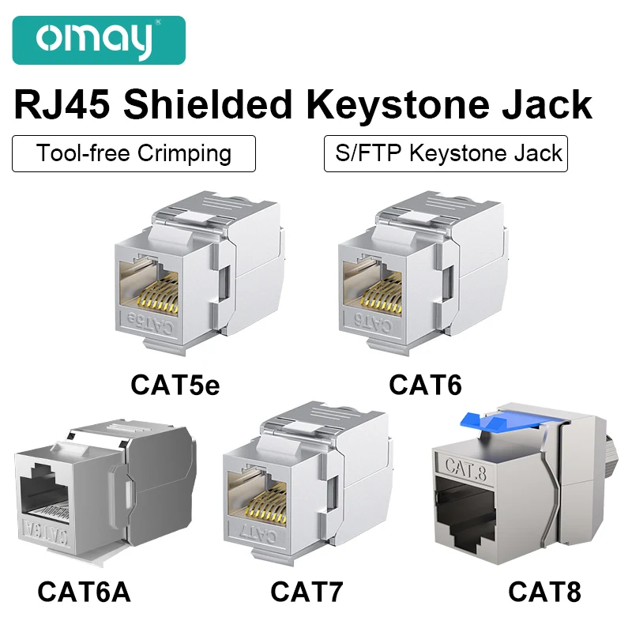

**Fig 1.8: Keystone Jacks**

**1.2 Wiring Details**

**1.2.1 Straight-Through Cable**

A straight-through cable is used to connect different types of devices, such as a computer

to a switch. The wiring configuration follows the T568A or T568B standard on both ends.

**Color Codes and Order (T568B):**

1. Orange/White

2. Orange

3. Green/White

4. Blue

5. Blue/White

6. Green

7. Brown/White

8. Brown

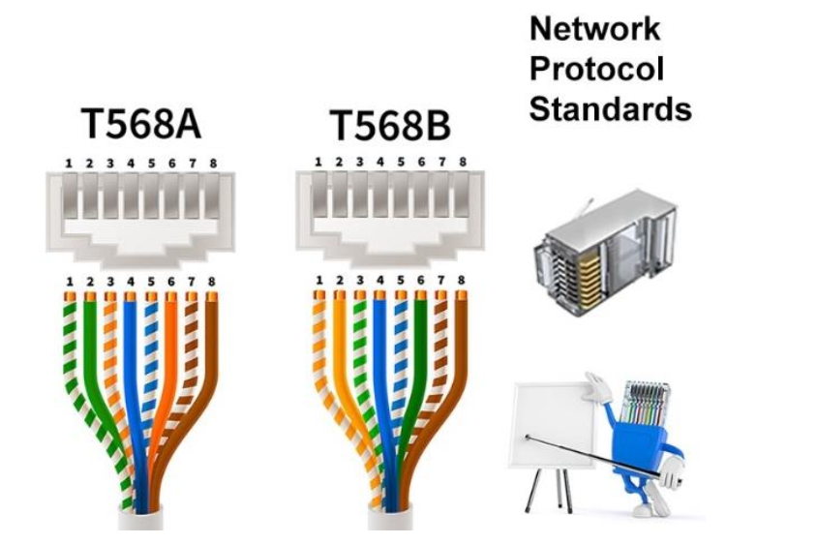

**Fig 2.1: Straight-Through Cable**

**2.2.2 Crossover Cable**

A crossover cable is used to connect similar devices, such as a computer to another

computer. One end of the cable follows the T568A standard, and the other end follows the

T568B standard.

**Color Codes and Order (T568A):**

|  |  |  |  |
| --- | --- | --- | --- |
| **1.** | **Side One** | **Side Two** | |
| 2. | Green/White | Orange/White | |
| 3. | Green | Orange | |
| 4. | Orange/White | Green/White | |
| 5. | Blue | Blue | |
| 6. | Blue/White | Blue/White | |
| 7. | Orange | Green | |
| 8. | Brown/White | Brown/White | |
| 9. | Brown | Brown | |
|  |  | |  |

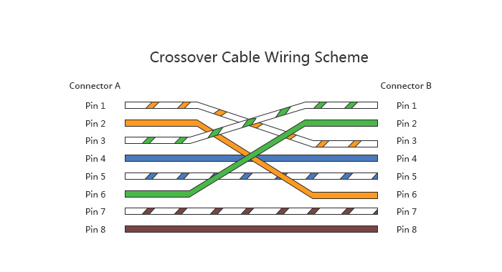

**Fig 2.1: Crossover Cable**

**3.1 Steps Required**

**3.1.1 Straight-Through Cable**

* Cut the UTP cable to the required length based on the connection distance.
* Strip approximately 1 inch of the outer jacket from both cable ends.
* Untwist the wire pairs and arrange them according to the T568B (or T568A) color code.
* Trim all wires evenly to ensure a clean and level insertion.
* Insert the arranged wires into RJ-45 connectors following the chosen standard.
* Use a crimping tool to secure the connectors onto the cable ends.
* Test the completed cable using a cable tester to ensure proper wiring.

**3.1.2 Crossover Cable**

* Cut the UTP cable to the appropriate length needed for the connection.
* Strip the outer jacket from both ends of the cable to expose the wires.
* Arrange one end of the cable in T568A and the other end in T568B color code.
* Trim the wires evenly and insert them carefully into the RJ-45 connectors.
* Crimp both ends of the cable securely using a crimping tool.
* Test the crossover cable using a cable tester to verify correct wiring.

**Conclusion**

This lab helped us understand the theory and practical implementation of Ethernet wiring. We learned the differences between straight-through and crossover cables, the standards used in their color-coding, and the specific purposes of each wiring type. We practiced building both cable types using proper tools and techniques. Understanding these concepts was essential for setting up reliable and structured wired LAN networks. The hands-on experience reinforced our theoretical knowledge and improved our technical confidence in network cabling.